Dunnikier Park Nursery & Playgroup welcome pack



Community Hall, Barry Road, Kirkcaldy, Fife, KY2 6JD
Tel: 01592 583207 or Email: dunnikierparkplaygroup@gmail.com
Manager Email: jasmine.mckinney.dunnikierpark@gmail.com
Scottish Charity number: SC008386

Welcome to Dunnikier Park Nursery and Playgroup!

All about us:

At Dunnikier Park Nursery & Playgroup, we are proud to provide a nurturing, inclusive and child-centred environment where every child is seen as unique and capable. Our vision is to work in close partnership with parents, carers, and the wider community to create a warm, welcoming space where all children feel valued and supported in reaching their full potential. Guided by our core values of Curiosity, Achievement, Responsibility, and Equity, we offer rich learning opportunities that inspire children to explore, grow, and lead their own learning journeys. Our playrooms are thoughtfully designed with open-ended and natural resources to spark curiosity and encourage independent thinking. We promote wellbeing, respect, and a strong sense of belonging for all. As a proud partner provider with Fife Council, we are able to offer funded nursery places, supporting families with high-quality early learning and childcare. At the heart of everything we do is the belief that children thrive best when they are at the centre of their own learning, supported by trusted adults working in genuine partnership.

Meet the staff:
At Dunnikier Park Nursery & Playgroup, our team is at the heart of everything we do. We are a nurturing, welcoming, and passionate group of early years professionals who are dedicated to providing the highest quality of care and education. Each member of our staff is skilled, knowledgeable, and committed to creating a safe, stimulating environment where every child feels valued and supported. We take pride in building strong, trusting relationships with children and families, and in continuously developing our practice to ensure the best outcomes for all.



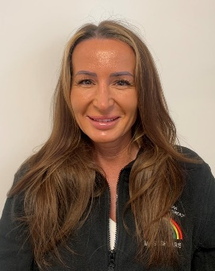
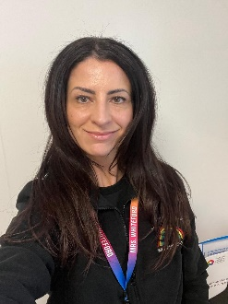


Mrs O’Neill
Lead Practitioner
Miss Mckinney
Manager
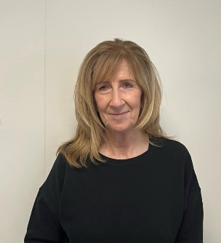
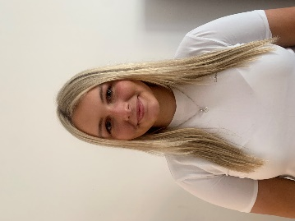
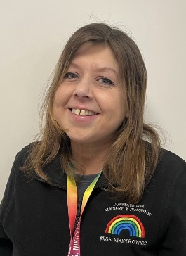
Mrs Smart
Supply EYO

Miss Stuart
Supply EYO

Miss Nikiperowicz
EYO

Mrs Whiteford
EYO

Mrs Spears
EYO

Miss Livingston
EYO

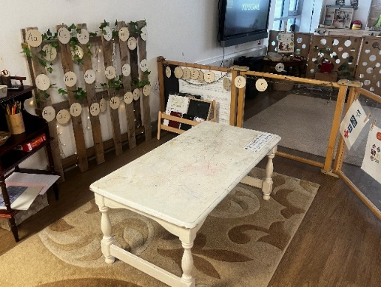
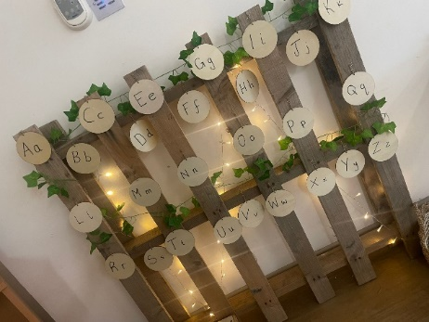
Our Space

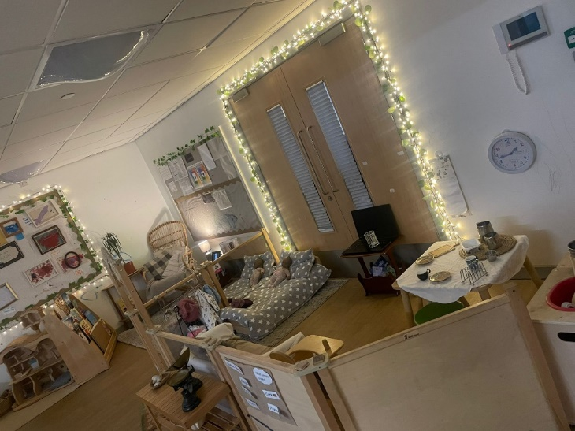

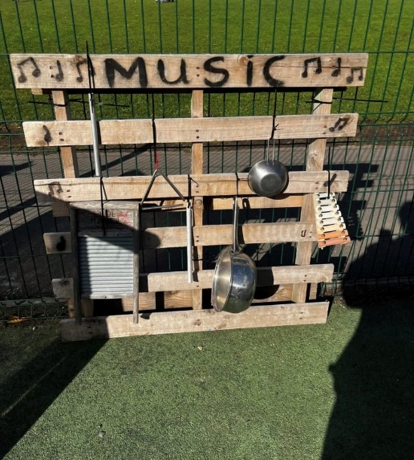
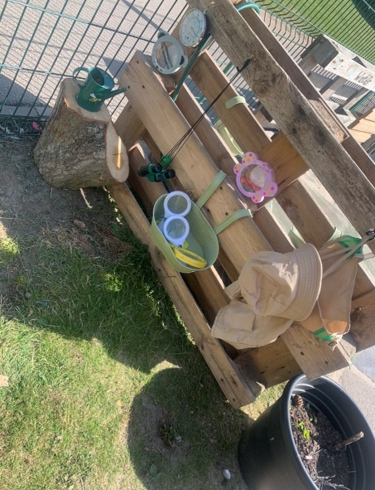

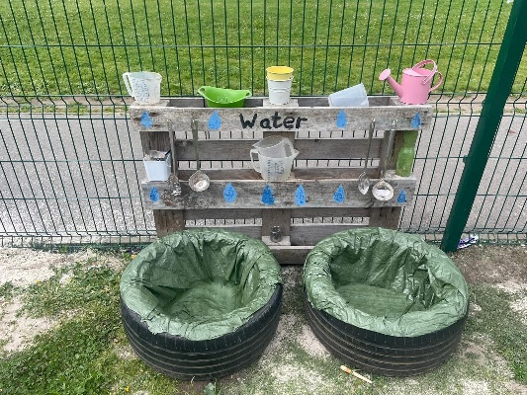

Our sessions:

We are situated in the Community Hub in the grounds of Capshard Primary School. We are registered for 26 children aged from 2 years 6 months to pre-school.
Our sessions are
Monday to Friday 08:45 to 11:55 am
Monday to Friday 11:55 to 2:45 pm
Monday to Friday 08:45 to 14:45 full day
Fee per session for 2½ year olds is
Am- £18
Pm- £18
Full day- £36
Fees are payable even if your child is absent.
Bank account sort code: 80-16-84
Account number 00431153.
Fees must be paid every Monday on a Weekly basis unless arrange otherwise with Manager.
Please note that Children will be funded from the first funding date following their third birthday.

Settling in:

After enrolment, you will receive your child’s start date, marking an exciting new chapter for both of you. We understand that the first few sessions may be a little challenging, and it’s perfectly normal for your child to feel unsettled as they adjust to this new environment. Our caring staff are well prepared to support your child through this transition, offering gentle encouragement and reassurance as they explore their new surroundings. Throughout their first day we will keep you updated on how they are doing.

Our Aims, Visions & Values :

Our Vision:
At Dunnikier Park Nursery & Playgroup we aim to work in partnership with parents and carers to provide a warm, welcoming and caring environment where all children are equal, valued and are provided with the best possible learning opportunities to enable them to reach their full potential.

Our Values:
C – Curiosity- Children to have access to spaces and experiences to spark their curiosity.
A – Achievement- Allowing children to reach their full potential.
R- Responsible – Children to have ownership of their own learning.
E- Equity- Inclusive to all children.

Our Aim:
- Provide a safe, caring and stimulating environment where every child is treated as an individual.
- Promote wellbeing and respect.
- Create a playroom that provides open ended and natural resources to spark curiosity.
- Work together with all parents and carers, external agencies and the wider community to meet the needs of all individuals.

Clothing
We love to get messy while learning and having fun, so we kindly ask that children come dressed in old, comfy clothes they can move freely in. We encourage a change of clothing in your child’s bag, just in case!
As we play and learn outdoors in all kinds of weather, please make sure your little one has cosy layers, a warm jacket, and labelled wellies. Please also bring an all-in-one waterproof suits for outdoor adventures. Whether we’re exploring the woods, visiting the local shops, or simply splashing in puddles, your child will be part of it all!

Snack Time
We offer a healthy, nourishing snack each day, including fresh fruit and milk. The cost for this is £20 per term. If your child has any dietary needs or allergies, just let our team know—we’ll work with you to ensure they’re fully supported.
For those attending a full day or PM session, lunch is provided.
Please note: we are a NUT-FREE setting to help protect children with allergies.
We kindly ask that sweets, chocolate, and crisps are not brought in, to help us promote healthy eating and keep all children safe—especially those with allergies
Attendance
If your child isn’t able to come to a session, please give us a quick call on 01592 583207 by 9:30am or email us at dunnikierparkplaygroup@gmail.com.

Illness
To keep everyone safe and well, we ask that children stay home for 48 hours after any sickness or diarrhoea. If your child has a contagious illness, please let us know straight away so we can take appropriate steps to protect others.
Unfortunately, fees still apply even if your child is unwell or off for the day, but we appreciate your understanding and support.

Staying Connected
We love building strong, positive relationships with our families. To help keep you in the loop, we offer:
- A private, closed Facebook group
- Regular emails and updates
- A monthly newsletter
- Your child’s Personal Learning Journal (PLJ)
- A dedicated Keyworker to support your child
- Opportunities to be part of our parent-run committee

A Few Little Reminders
- The main entrance is secure and operated by staff via a door bell, please tell staff if your child plans on being picked up by someone different on the day.
- The car park is for staff only, though Blue Badge holders may use the accessible space.
- We kindly ask that toys from home stay at home.

Working Together
At Dunnikier Park Nursery and Playgroup, we truly value the partnerships we build with our families. Our warm, approachable team is always here for you and your child. We believe in open communication, shared goals, and creating a welcoming environment where every child can flourish.
We’re so excited to have you join our playgroup family—and we look forward to getting to know you and your little one! 🌈

Kindest Regards
Jasmine, Jenna, Karen, Lauren, Gaby, Joanne, Fiona and Summer

